LAB REPORT – 2
EXPERIMENT 1
LOGIC LEVELS

NAME : Basireddy Khyathi Sri
ROLL NO : 2023102065
GROUP : 6

Objective:
To find the pivotal voltage of change of logic level in the input and output using a
multimeter and potentiometer.

Electronic Components Required:
1. Digital Testing Kit
2. NOT Gate (IC 7404)
3. Potentiometer
4. Multimeter
5. Power Source
6. 1kΩ Resistor

Reference Circuit:

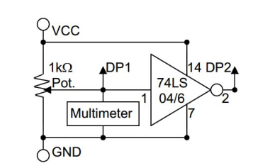
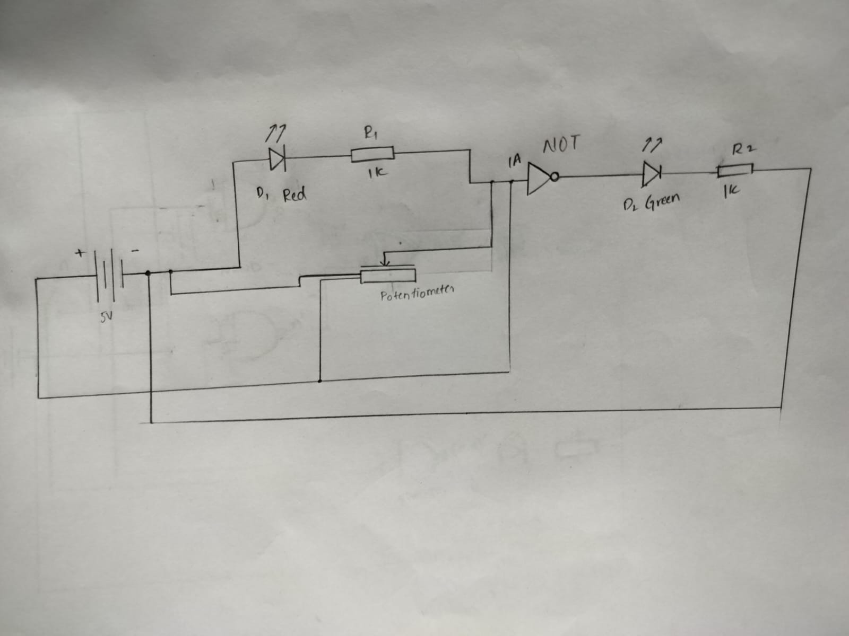
TinkerCad Simulation:

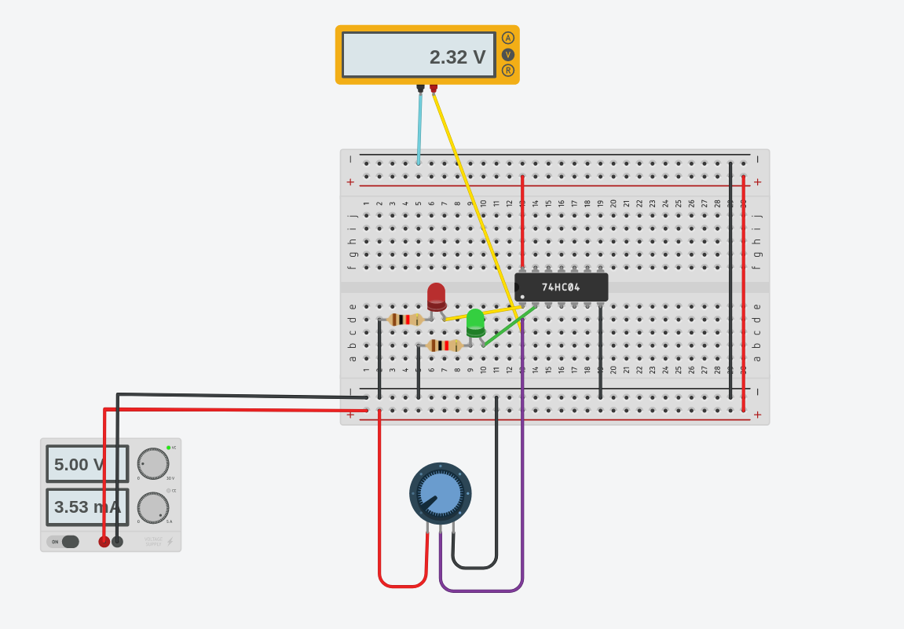

Procedure:
1. The IC is connected to the power source in the digital test kit.
2. The left and right terminals of the potentiometer are connected to the GND and VCC respectively.
3. The middle terminal of the potentiometer is connected as the input of a NOT gate, and to the display pin 1.
4. The output of the NOT gate is connected to display pin 2.
5. The positive terminal of the multimeter is simultaneously placed at the display pins 1 and 2 while the resistance across the potentiometer is slowly changed.
6. Multimeter is used to measure the change the potential difference across the ground and output of potentiometer.
7. Note the readings on the multimeter when the color at display pins start to change.

Observations:
1. On rotating the knob of the potentiometer clockwise,
the reading of the multimeter increases.
2.The ranges of the original voltages are
0 ≤ V_{OL} ≤0.4, 0 ≤ V_{IL}​≤ 0.8, 2.0 ≤ V_{IH} ≤ 5.0, 2.4 ≤ V_{OH}≤ 5.0.
The observed voltages are:
V_{OH} = 2.55V
V_{IL} = 0.76V
V_{IH} = 2.38V
V_{OL} = 0.34V

Hence the observed voltages are in the required range.

Conclusion:
The logic levels when implemented in circuit, don’t have
exact discrete voltages. There is a tolerable range. For the IC
7404, a significant logic level change can be observed at
1.83V.

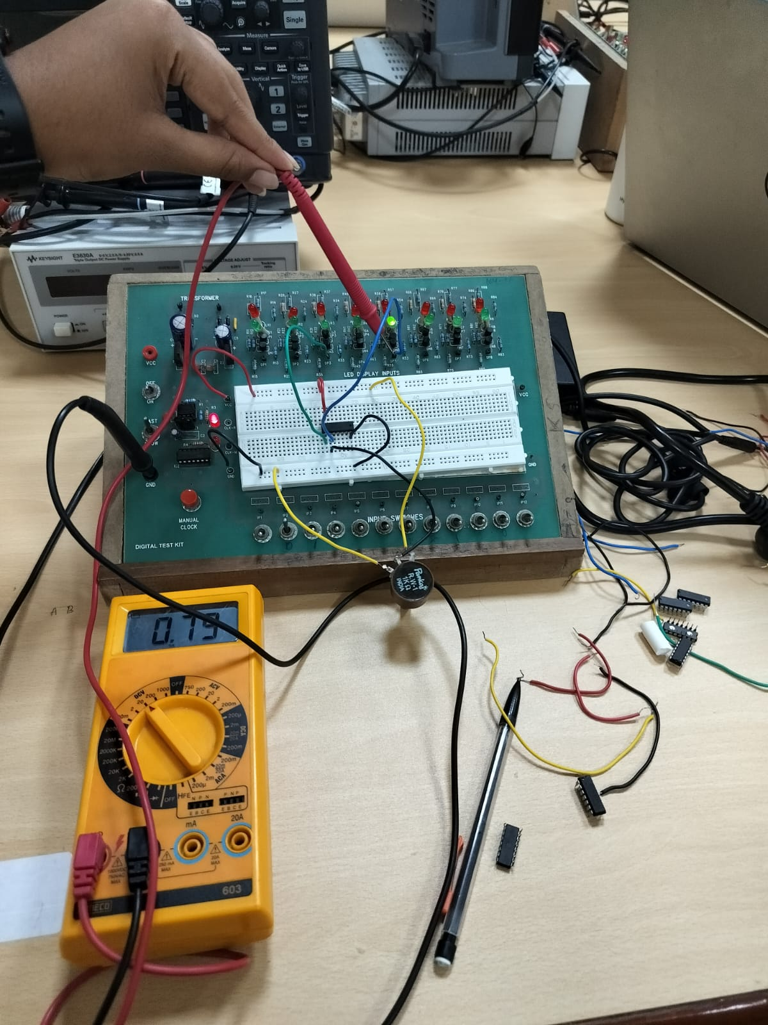
TinkerCad Simulation Link:

https://www.tinkercad.com/things/2X9YPBsyf5u-part-a-logic-levels-/editel?sharecode=DZyjOBHdBd_Y-mAy9AyFNBYwdvD2F_lrKqCWR1gsKCk

EXPERIMENT – 2
GATES IDENTIFICATION

1) AND Gate

Objective : To identify different and verify logic gates.

Electronic Components required :
1) Breadboard
2) A logic gate(Integrated Circuit or IC)
3) Slide switch
4) LED
5) Connecting wires
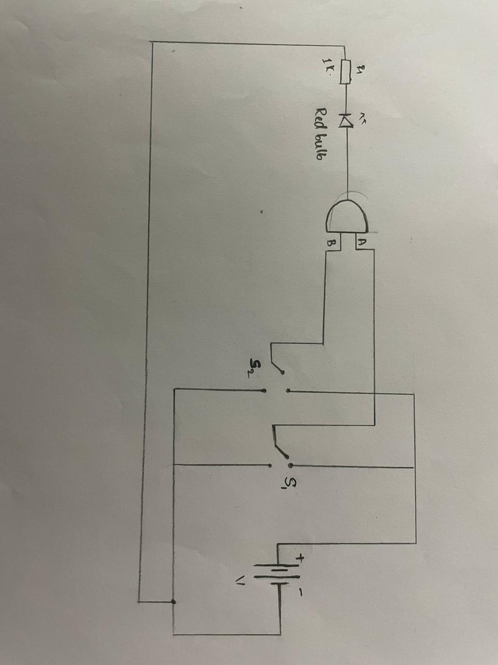
6) A battery

The Reference Circuit :

TinkerCad Simulation:

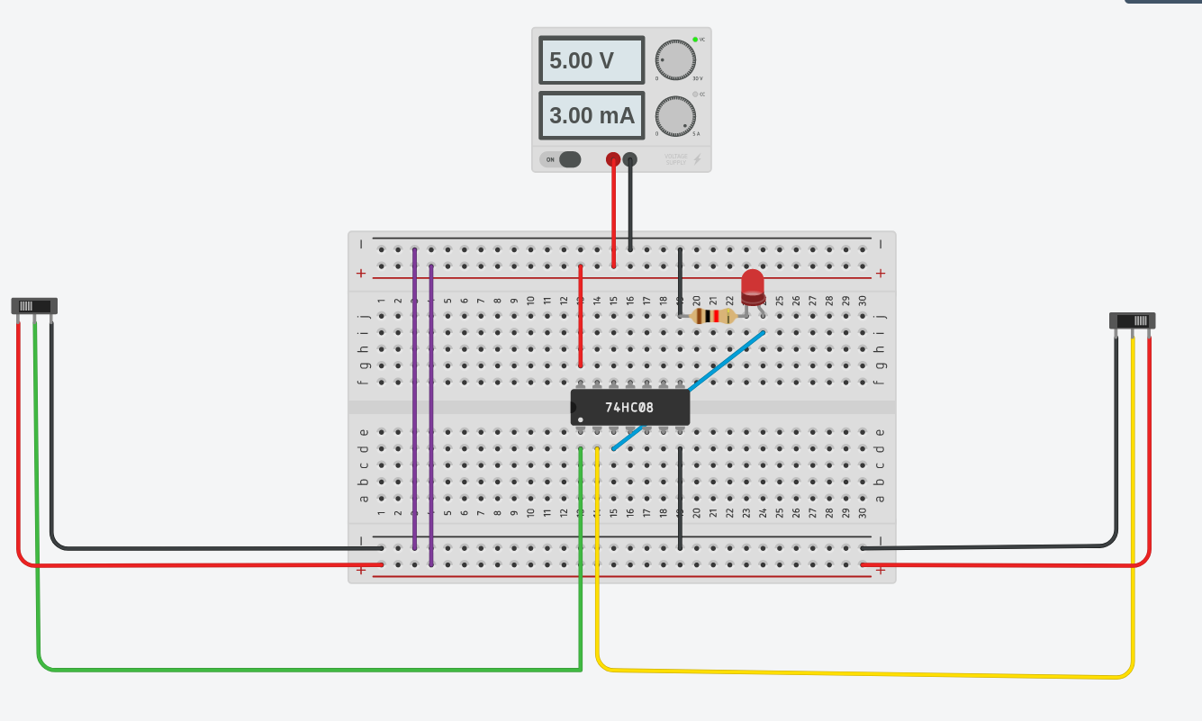
Procedure :
1. Connect the VCC and Gnd pins of the IC to the VCC and Gnd
lines on the top and the bottom of the breadboard, using RED and
BLACK wires respectively.
2. Connect the two input pins of any one gate in the IC to two of the
IP1-IP12 input switches, and the corresponding output pin of the IC to
one of the DP1-DP8 display points provided in the Test Kit.
3. Apply the four possible combinations of (binary) values to the gate
inputs one by one by means of the input switches and tabulate the
corresponding values of the gate output as observed on the LED
display to obtain the truth table of the gate.
4. Verify that all the four gates in the IC are identical by repeating
steps 2 and 3 for the other three gates in the same IC.

Observation :
1) When input 1 is HIGH and input 2 is HIGH, the observed output is
HIGH
2)When any one output is LOW, or both the outputs are LOW, the
output is LOW.

Truth Table :
INPUT 1 | INPUT 2 | OUTPUT
0 | 0 | 0
0 | 1 | 0
1 | 0 | 0
1 | 1 | 1

Conclusion : The given IC - SN74HC08N is an AND gate, as it follows
the logical expression A.B.

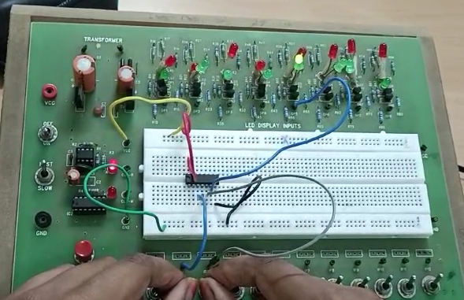

TinkerCad Simulation Link:

https://www.tinkercad.com/things/dknZYgVHqLu-part-b-gate-identification-and/editel?sharecode=EJkdLGCdKLYWKv0hFilvYbNEBtijsO40ZnMGv4hl7Eo

2)OR Gate:

Objective : To identify different and verify logic gates.

Electronic Components required :
1) Breadboard
2) A logic gate(Integrated Circuit or IC)
3) Slide switch
4) LED
5) Connecting wires
6) A battery

The Reference Circuit :
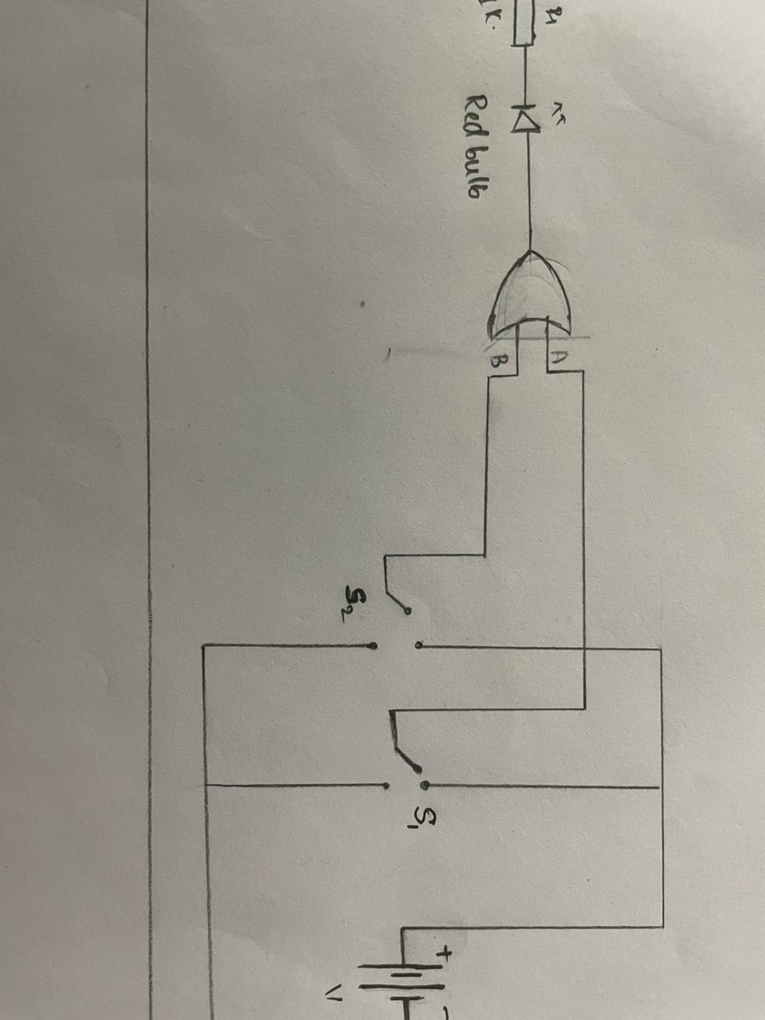

TinkerCad Simulation:

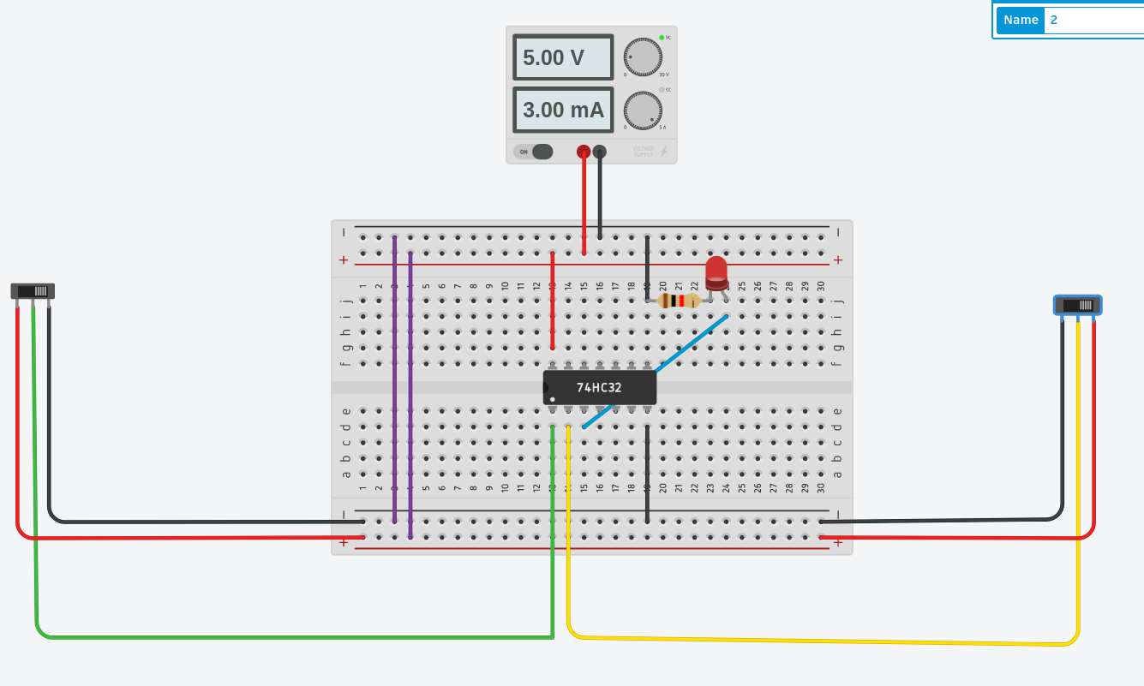

Procedure :
1. Connect the VCC and Gnd pins of the IC to the VCC and Gnd
lines on the top and the bottom of the breadboard, using RED and
BLACK wires respectively.
2. Connect the two input pins of any one gate in the IC to two of the
IP1-IP12 input switches, and the corresponding output pin of the IC to
one of the DP1-DP8 display points provided in the Test Kit.
3. Apply the four possible combinations of (binary) values to the gate
inputs one by one by means of the input switches and tabulate the
corresponding values of the gate output as observed on the LED
display to obtain the truth table of the gate.
4. Verify that all the four gates in the IC are identical by repeating
steps 2 and 3 for the other three gates in the same IC.

Observation :
1) When input 1 is HIGH and input 2 is HIGH, the observed output is HIGH.
2)When any one output is LOW, and the other input is HIGH, the output is HIGH
3)When both the inputs are LOW, the OUTPUT is LOW.

Truth Table :
INPUT 1 | INPUT 2 | OUTPUT
0 | 0 | 0
0 | 1 | 1
1 | 0 | 1
1 | 1 | 1

Conclusion : The given IC - SN74HC32N is an OR gate as it follows
the logical expression A+B

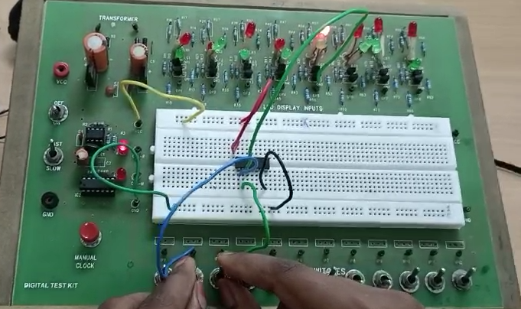

TinkerCad Simulation Link:

https://www.tinkercad.com/things/4hzotkH9oOM-part-b-gate-identification-or/editel?sharecode=_AtkkZyUypXsZmv1TWX4whWFkR3rSE_B-H2W_UUwvKI

3)NAND Gate:

Objective : To identify different and verify logic gates.

Electronic Components required :
1) Breadboard
2) A logic gate(Integrated Circuit or IC)
3) Slide switch
4) LED
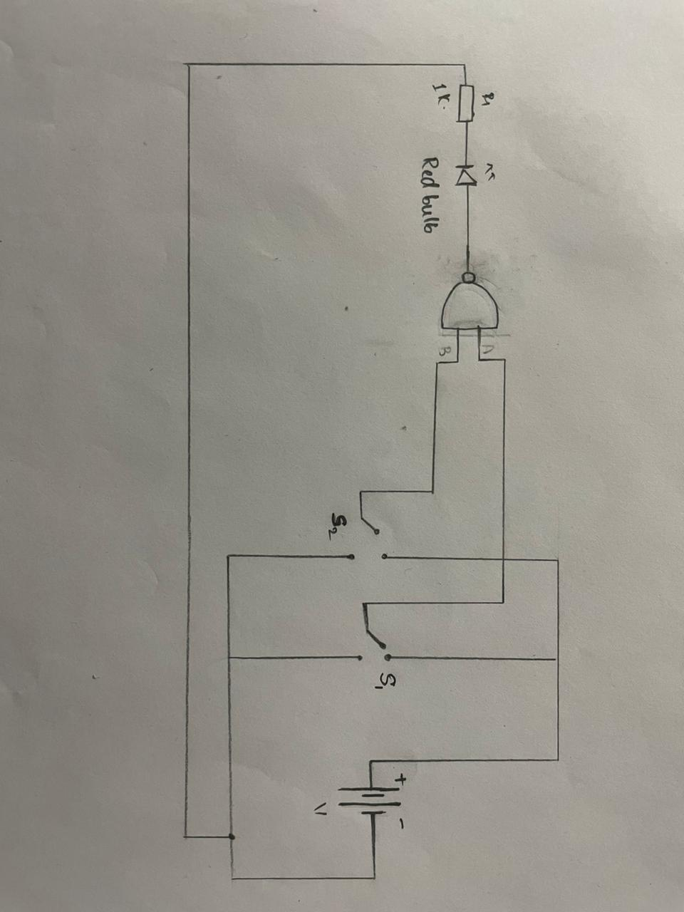
5) Connecting wires
6) A battery

The Reference Circuit :

TinkerCad Simulation:
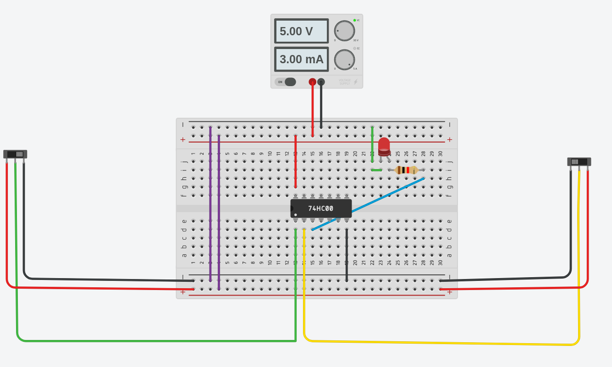

Procedure :
1. Connect the VCC and Gnd pins of the IC to the VCC and Gnd
lines on the top and the bottom of the breadboard, using RED and
BLACK wires respectively.
2. Connect the two input pins of any one gate in the IC to two of the
IP1-IP12 input switches, and the corresponding output pin of the IC to
one of the DP1-DP8 display points provided in the Test Kit.
3. Apply the four possible combinations of (binary) values to the gate
inputs one by one by means of the input switches and tabulate the
corresponding values of the gate output as observed on the LED
display to obtain the truth table of the gate.
4. Verify that all the four gates in the IC are identical by repeating
steps 2 and 3 for the other three gates in the same IC.

Observation :
1) When input 1 is HIGH and input 2 is HIGH, the observed output is LOW.
2)When any one output is LOW, and the other input is HIGH, the output is HIGH
3)When both the inputs are LOW, the OUTPUT is HIGH.

Truth Table :
INPUT 1 | INPUT 2 | OUTPUT
0 | 0 | 1
0 | 1 | 1
1 | 0 | 1
1 | 1 | 0

Conclusion : The given IC – 74HC00 / CD4011BE an NAND gate as it follows
the logical expression(A.B)’.

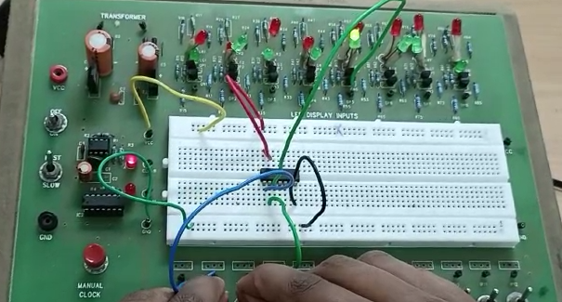

TinkerCad Simulation Link:

https://www.tinkercad.com/things/930jxLmbclh-part-b-gate-identification-nand/editel?sharecode=5EWfz-5lk9FK6h4NPLSuK6rzIK8zT-CiQ-LhcwL8iF0

4)NOR Gate:

Objective : To identify different and verify logic gates.

Electronic Components required :
1) Breadboard
2) A logic gate(Integrated Circuit or IC)
3) Slide switch
4) LED
5) Connecting wires
6) A battery

The Reference Circuit :

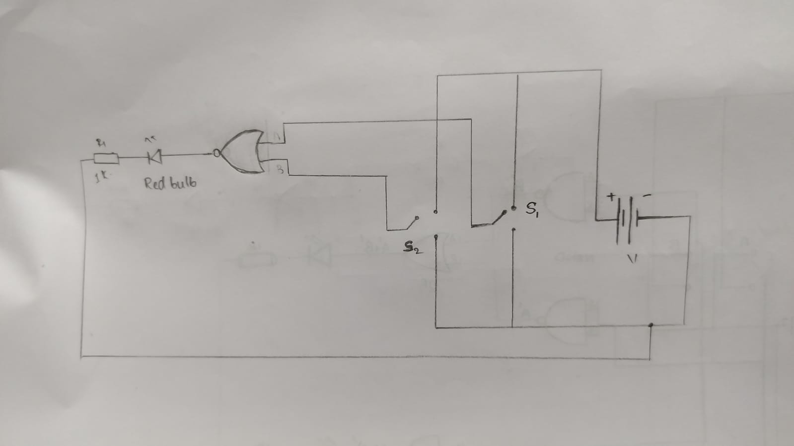

TinkerCad Simulation:
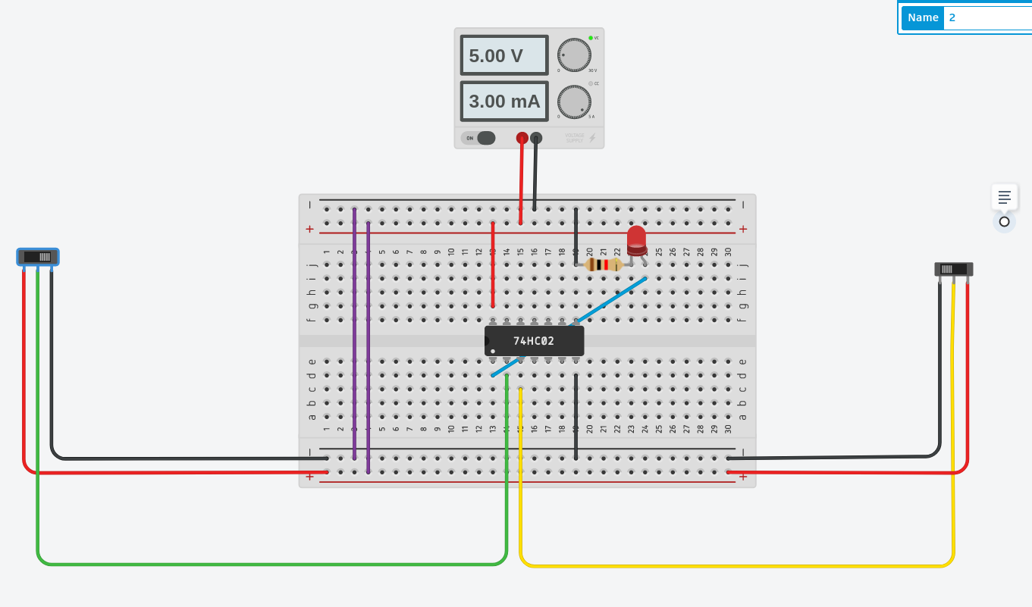

Procedure :
1. Connect the VCC and Gnd pins of the IC to the VCC and Gnd
lines on the top and the bottom of the breadboard, using RED and
BLACK wires respectively.
2. Connect the two input pins of any one gate in the IC to two of the
IP1-IP12 input switches, and the corresponding output pin of the IC to
one of the DP1-DP8 display points provided in the Test Kit.
3. Apply the four possible combinations of (binary) values to the gate
inputs one by one by means of the input switches and tabulate the
corresponding values of the gate output as observed on the LED
display to obtain the truth table of the gate.
4. Verify that all the four gates in the IC are identical by repeating
steps 2 and 3 for the other three gates in the same IC.

Observation :
1) When input 1 is HIGH and input 2 is HIGH, the observed output is HIGH.
2)When any one output is LOW, and the other input is HIGH, the output is LOW.
3)When both the inputs are LOW, the OUTPUT is LOW.

Truth Table :
INPUT 1 | INPUT 2 | OUTPUT
0 | 0 | 1
0 | 1 | 0
1 | 0 | 0
1 | 1 | 0

Conclusion : The given IC - 74HC02/CD4001BE is an NOR gate as it follows
the logical expression(A+B)’.

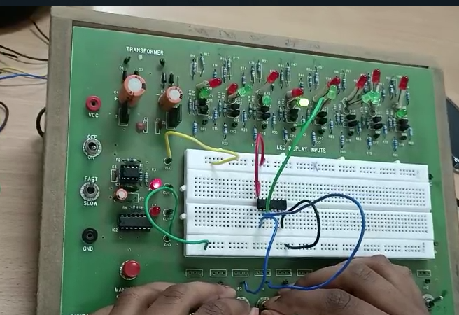

TinkerCad Simulation Link:

https://www.tinkercad.com/things/4AT1qzlZ8nB-part-b-gate-identification-nor/editel?sharecode=828FXd41PkPRxYNk6WFdLUBR1163T2c5GAbTsx0q4l8

5)XOR Gate:

Objective : To identify different and verify logic gates.

Electronic Components required :
1) Breadboard
2) A logic gate(Integrated Circuit or IC)
3) Slide switch
4) LED
5) Connecting wires
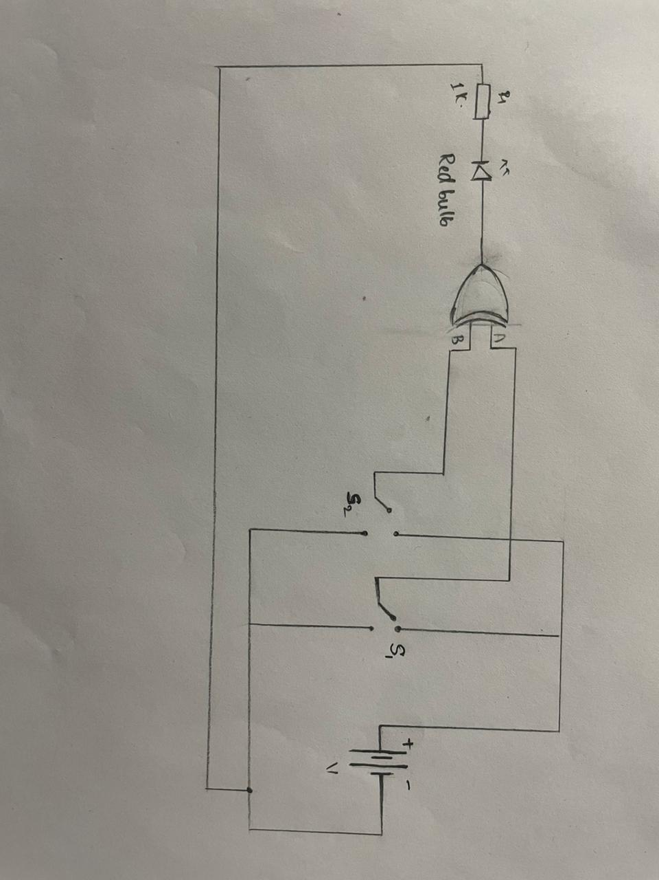
6) A battery

The Reference Circuit :

TinkerCad Simulation:

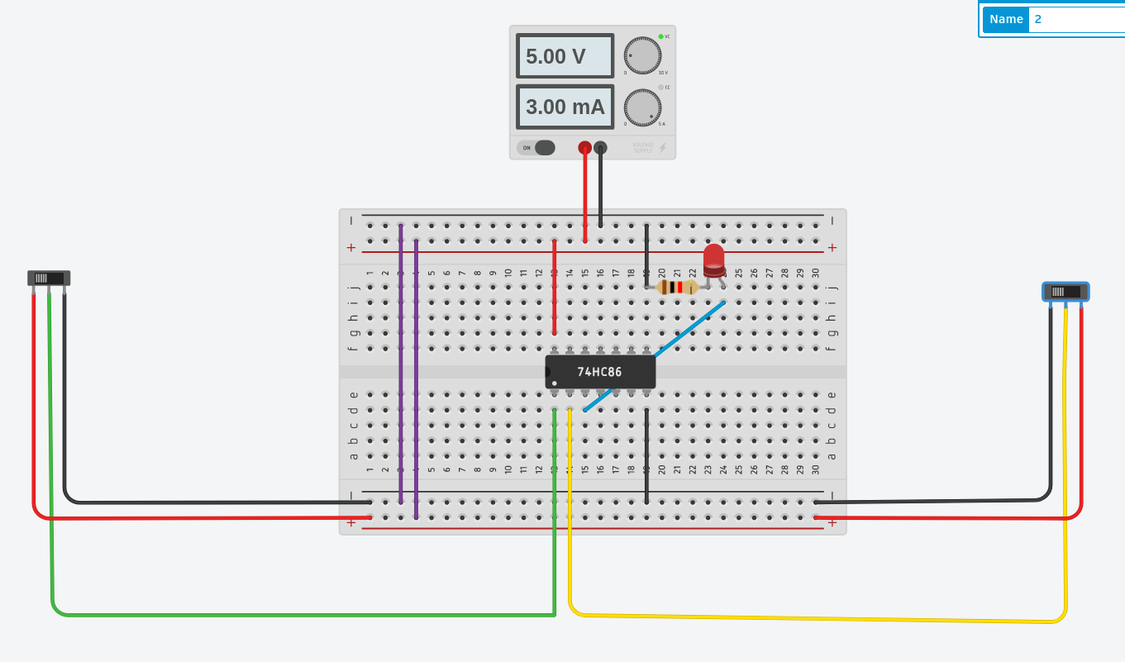

Procedure :
1. Connect the VCC and Gnd pins of the IC to the VCC and Gnd
lines on the top and the bottom of the breadboard, using RED and
BLACK wires respectively.
2. Connect the two input pins of any one gate in the IC to two of the
IP1-IP12 input switches, and the corresponding output pin of the IC to
one of the DP1-DP8 display points provided in the Test Kit.
3. Apply the four possible combinations of (binary) values to the gate
inputs one by one by means of the input switches and tabulate the
corresponding values of the gate output as observed on the LED
display to obtain the truth table of the gate.
4. Verify that all the four gates in the IC are identical by repeating
steps 2 and 3 for the other three gates in the same IC.

Observation :
1) When input 1 is HIGH and input 2 is HIGH, the observed output is LOW
2)When any one output is LOW, and the other input is HIGH, the output is HIGH
3)When both the inputs are LOW, the OUTPUT is LOW.

Truth Table :
INPUT 1 | INPUT 2 | OUTPUT
0 | 0 | 0
0 | 1 | 1
1 | 0 | 1
1 | 1 | 0

Conclusion : The given IC - SN74HC86 is an XOR as it follows
the logical expression AB’+A’B
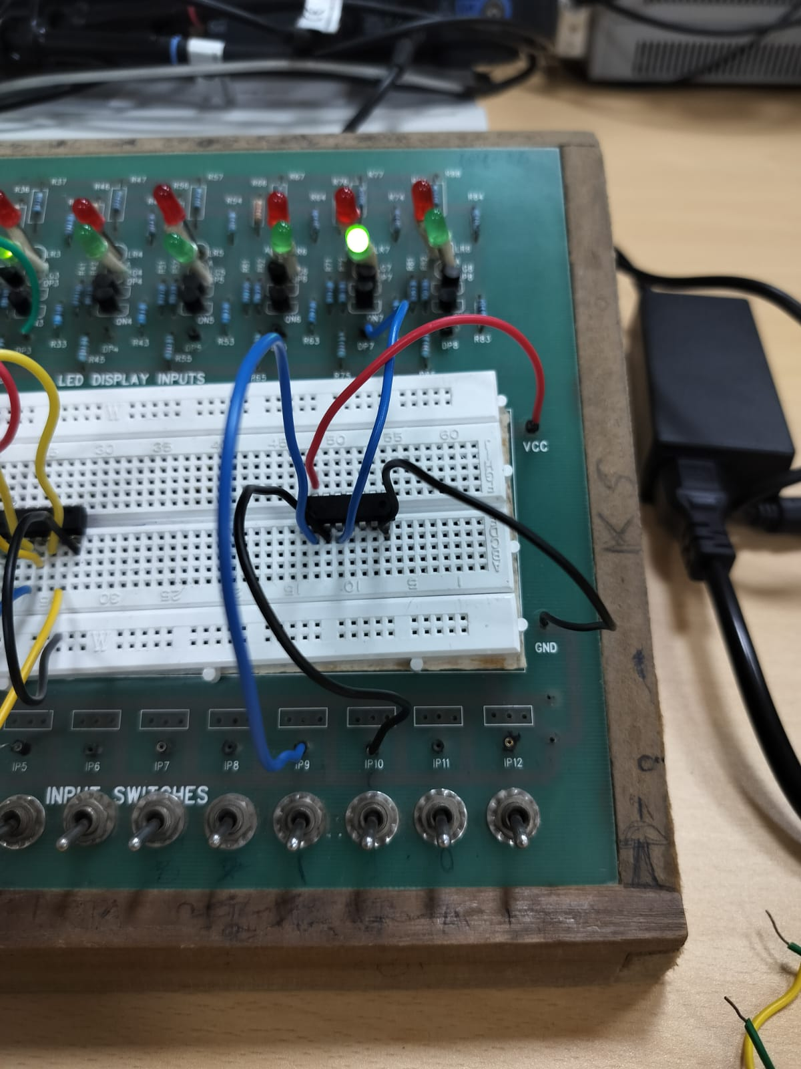
TinkerCad Simulation Link:

https://www.tinkercad.com/things/6XwJ4wOunO3-part-b-gate-identification-xor/editel?sharecode=dQZe7D3wl5FwkeKdnG1B5DmNb3rLqMKm_f76lBM-A2E

EXPERIMENT -3
DE-MORGAN’S LAWS

De Morgan’s theorems are as follows:
1) (A+B)’= A’. B’
2) (A.B)’=A’+B’

Objective: to verify De Morgan’s laws using gates
Electronic Components Required:
- Power supply
- LED
- Connecting wires
- Slide switch
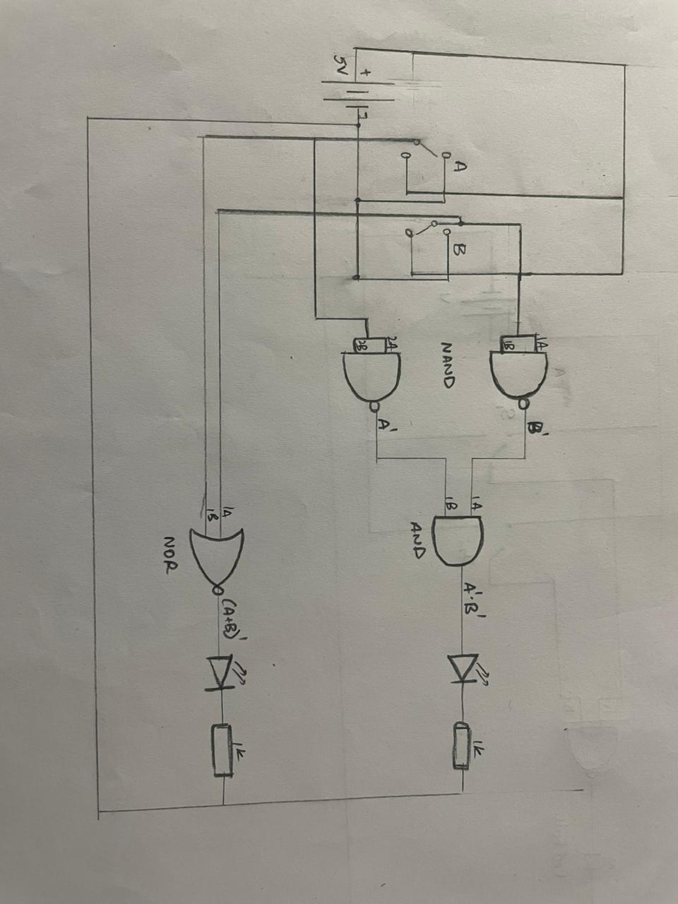
- Breadboard
- Logic gates (IC) – AND, NAND, XOR

Reference Circuit:

A’.B’=(A+B)’
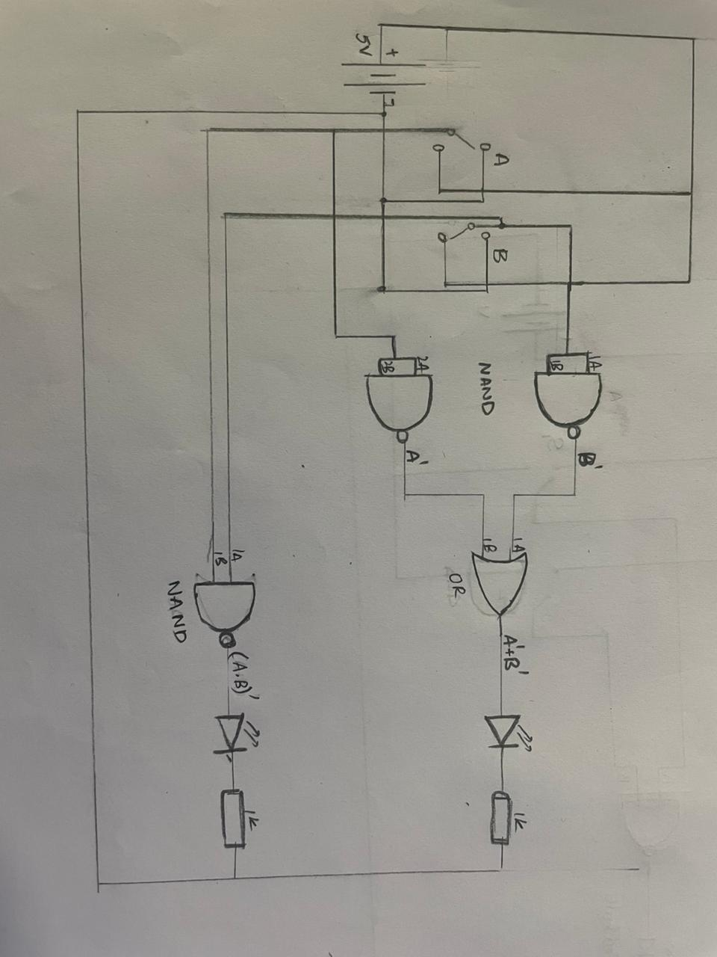
(A.B)’=A’+B’

TinkerCad Simulation:
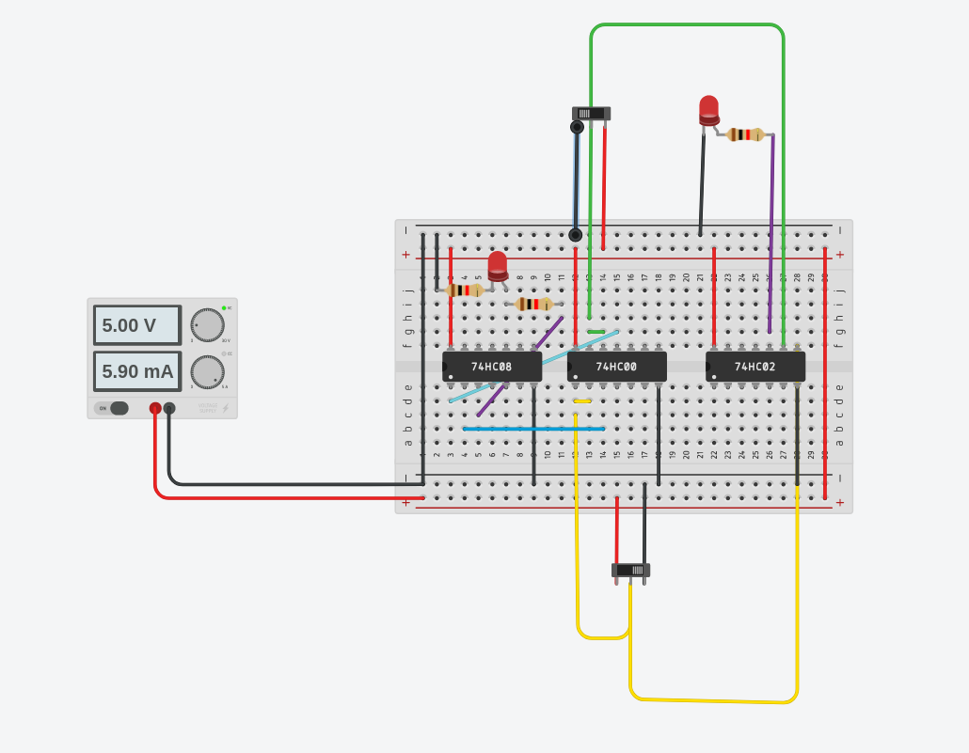
A’.B’=(A+B)’

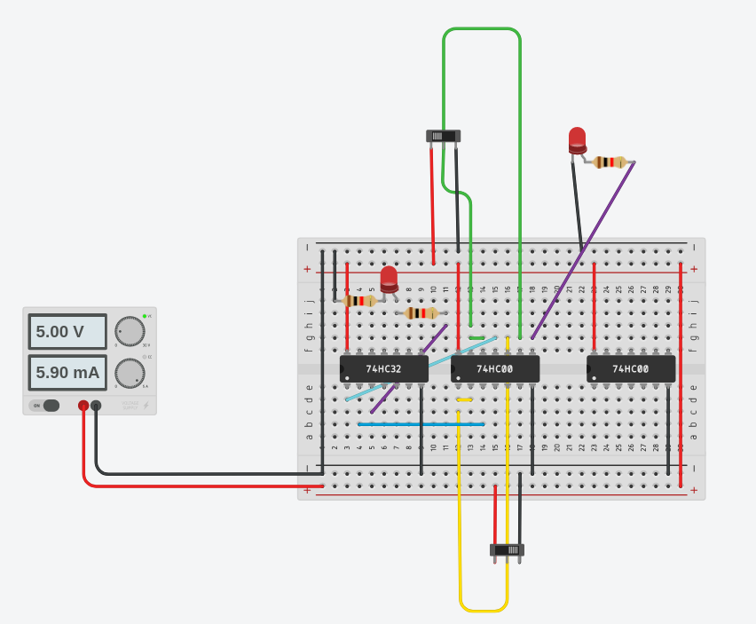
(A.B)’=A’+B’

PROCEDURE:
1) The VCC and GND pins of the IC must first be connected using RED
and BLACK wires to the VCC and GND lines on the top and bottom
of the breadboard, respectively. Connect the relevant output pin of
the IC to one of the DP1-DP8 display points provided in the Test Kit,
and the two input pins of any one gate in the IC to two of the IP1-
IP12 input switches. Connect one AND gate to one NAND gate, or set
up a circuit with two NAND gates and one AND gate ( from which we
are taking two inputs).
2)Now give the connections of input to these input holes. The output
of NAND gate from which the input is taken is connected to the input
terminals of AND gate. The output terminal of AND gate is connected
to a bulb which is inturn connected to a resistor and then to GND.
Make sure all the connections of VCC and GND are at equal
potential.
3)Obtain the truth table of this circuit by changing the values of the
switch provided.
4)Now while verifying RHS, connect an OR gate and a NOT gate (hex
invertor) to form a circuit. Take two input sources and connect them
to the input terminals of OR gate. The output of OR gate get
connected to the input of NOT gate. The output of NOT gate is
connected to a bulb which is inturn connected to GND through a
resistor.
5) Obtain the truth table by the changing the values of input in the
circuit.
6)Similar process is repeated for proving the second theorem.

Truth Table for (A.B)’=A’+B’
A | B | (A.B)’
0 | 0 | 1
0 | 1 | 1
1 | 0 | 1
1 | 1 | 0

A’ | B’ | A’+B’
1 | 1 | 1
1 | 0 | 1
0 | 1 | 1
0 | 0 | 0

Truth Table for A’.B’=(A+B)’
A’ | B’ | A’.B’
1 | 1 | 1
1 | 0 | 0
0 | 1 | 0
0 | 0 | 0

A | B | (A+B)’
0 | 0 | 1
0 | 1 | 0
1 | 0 | 0
1 | 1 | 0

OBSERVATION:
When both the inputs are negative ( or 0) then the bulb glows. In all
other cases the bulb not glows which means output is zero.

CONCLUSION:
So by seeing the above truth tables we can conclude that the
output for the series of NOT gates and AND gate is equal to the
NOR gate and similarly the circuit formed by NOT and OR series is
equal to NAND gate.

TinkerCad Simulation Link:

https://www.tinkercad.com/things/gmdETEkb9oM-abab/editel?sharecode=NCyQSXFucXgdxo_qnMYwsAwmyYfnj7G4d-lsvzIhGcY

https://www.tinkercad.com/things/hdpHfhLvtQ7-abab/editel?sharecode=t5R3yVdu1Y4iTv6tBpMKv77uZ0HHsBkEjG5BZtZYQWg

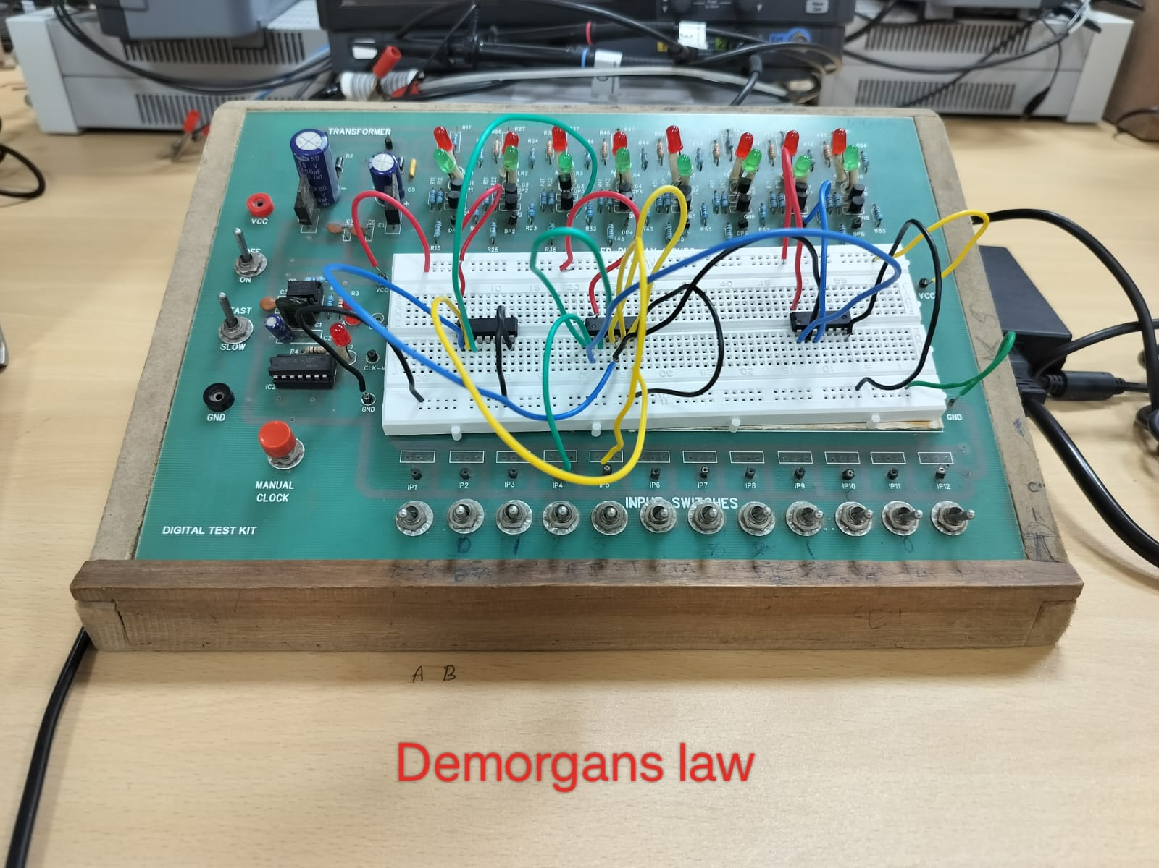

EXPERIMENT – 4
HALF ADDER AND FULL ADDER

OBJECTIVE: To construct a binary full adder from a half adder using gates.

Electronic Components Required:
- Breadboard
- Slide switch
- LED
- Connecting wires
- Power Supply
- Logic gates(IC)- AND,XOR

Reference circuit:

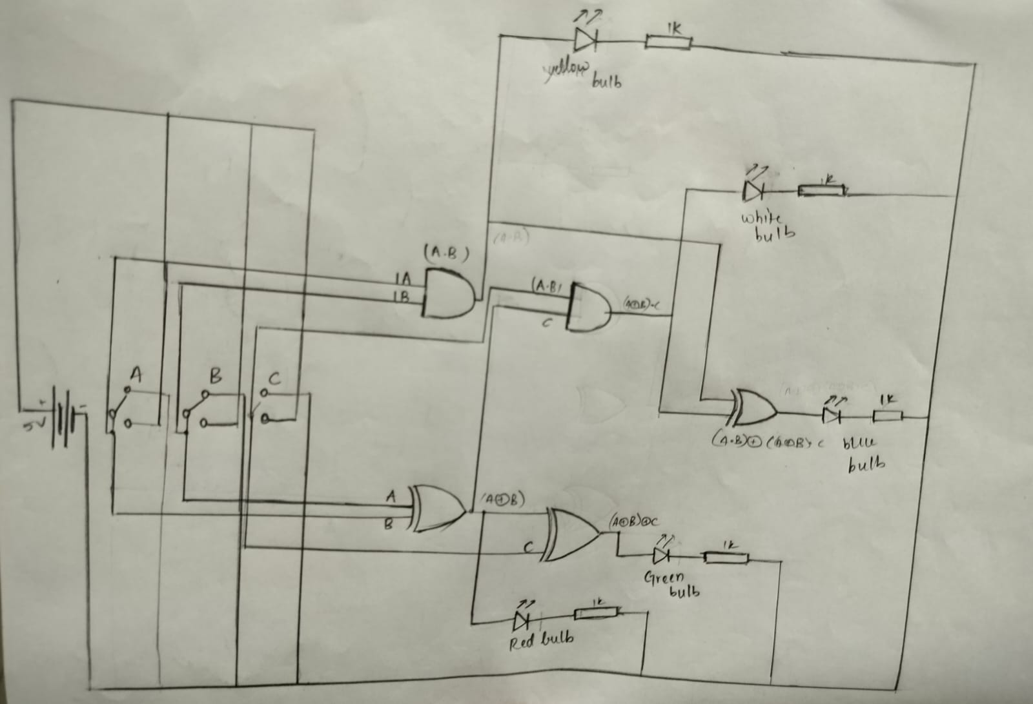

FULL ADDER:
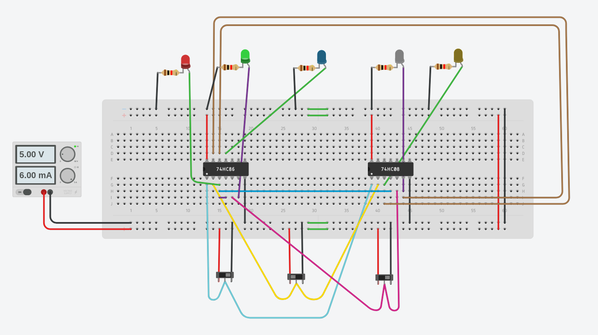

HALF ADDER:
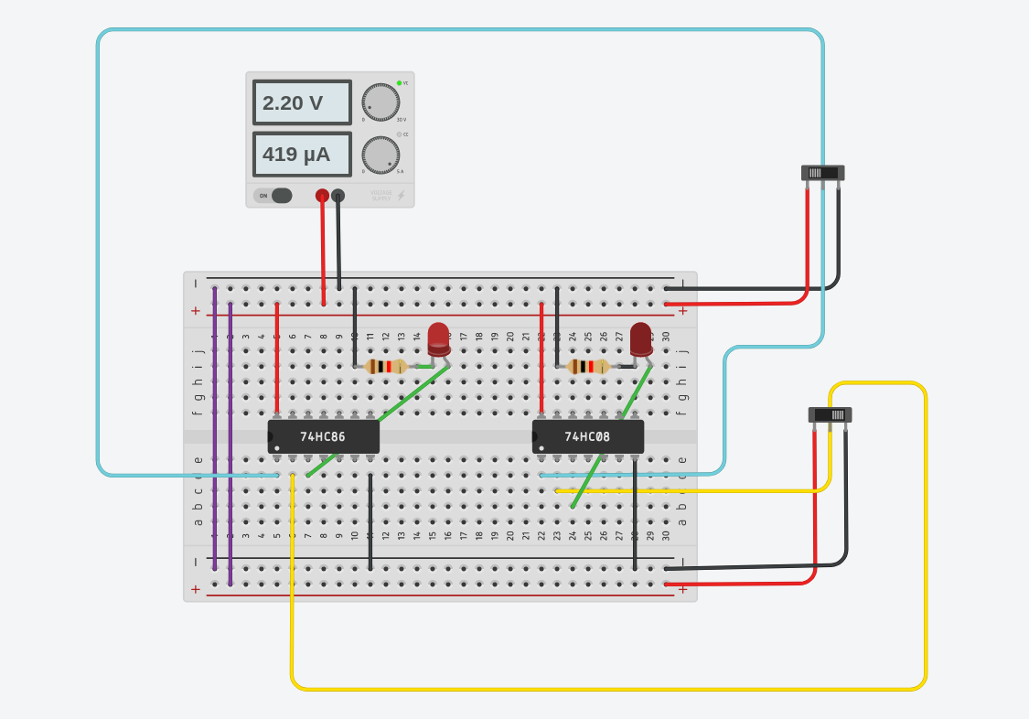
Procedure:
1) A binary full adder adds the bits A and B, as well as the carry in C,
to produce the output bits SUM and CARRY. Making a binary half
adder is the first step in accomplishing this. It adds two binary inputs,
A and B, and produces the sum S1 and carry C1, which are
determined by the following boolean formulas for the outputs S1
and C1.
C1 = A. B
S1 = A'. B + A. B' = A B.
2)Use an XOR gate and an AND gate to set up the circuit for a half
adder. Apply the inputs A and B from the two input switches, and for
every combination of the inputs, watch the outputs S1 and C1 on the
two LED screens. Put these values in a table and verify
3) The third binary input C is then added to the S1 bit produced by
the first Half Adder, which is then utilized to form the final SUM:
SUM = S1 ⊕ C
This half adder is created by connecting the C input and the S1
output produced by the first half adder as its inputs to produce the
final SUM and the C2 output using a second XOR gate and AND gate
using the same IC.
4) C2 = S1 determines the carry bit produced by this half adder. C
5) Utilizing the unutilized gates in the XOR and AND ICs currently in
use, create the final CARRY output from the intermediate carry
outputs C1 and C2.
6) After that, we will create a full adder truth table with columns for
the intermediate outputs S1, C1, and C2.
1) Verify the truth table experimentally by applying the inputs A, B
and C through three input switches and displaying the S1, C1,
C2, SUM and CARRY outputs.

TRUTH TABLE:
A | B | C | S1 | C1 | SUM | C2 | CARRY
0 | 0 | 0 | 0 | 0 | 0 | 0 | 0
0 | 0 | 1 | 0 | 0 | 1 | 0 | 0
0 | 1 | 0 | 1 | 0 | 1 | 0 | 0
0 | 1 | 1 | 1 | 0 | 0 | 1 | 1
1 | 0 | 0 | 1 | 0 | 1 | 0 | 0
1 | 0 | 1 | 1 | 0 | 0 | 1 | 1
1 | 1 | 0 | 0 | 1 | 0 | 0 | 1
1 | 1 | 1 | 0 | 1 | 1 | 0 | 1

OBSERVATION:
There are all the four cases we have checked
000 : carry=0 and sum=0
001 : carry=0 and sum=1
010 : carry=0 and sum=1
011 : carry=1 and sum=0
100 : carry=0 and sum=1
101 : carry=1 and sum=0
110 : carry=1 and sum=0
111 : carry=1 and sum=1

With these the input and output the bulb has glown.

Conclusion:
We are fully aware of how to use the gates up to our use, and as
carry is actually we can say C1 or C2, but we found out by De
Morgan's law and verified it that C1 xor C2 would result in the same
values. I learned about the functions of the binary full adder, and I
verified the truth table we got with the original it is same as we got.

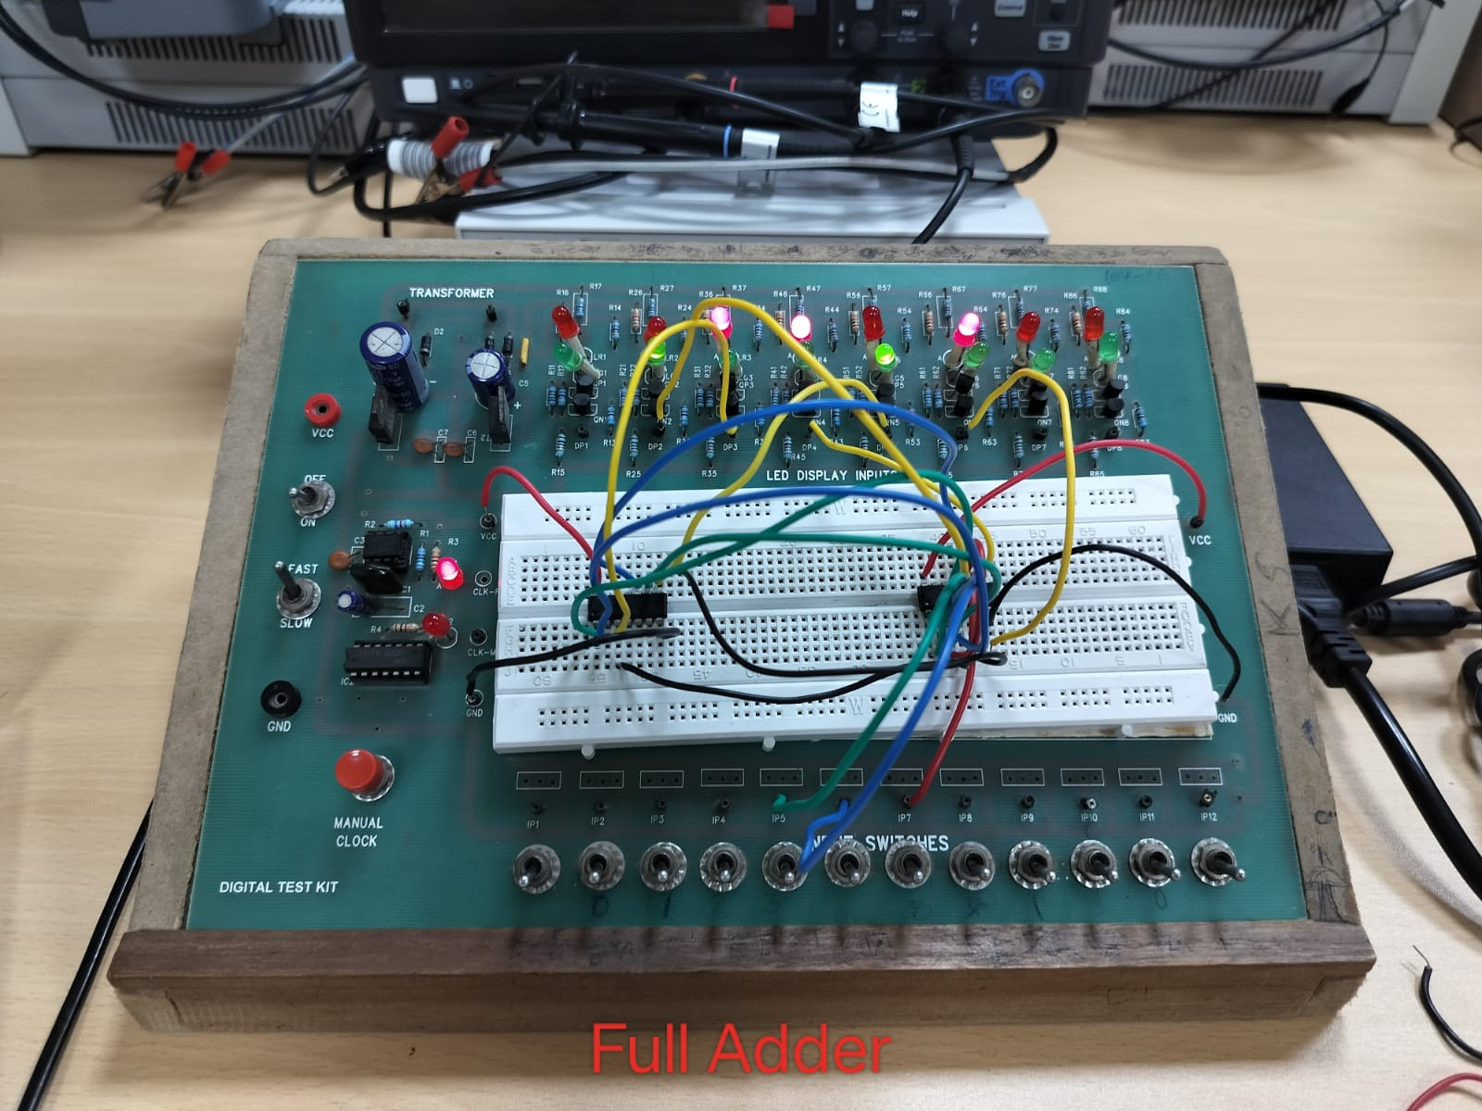

TinkerCad Simulation Link:

Half Adder
https://www.tinkercad.com/things/ctpRvmkFXGO-half-adder/editel?sharecode=mQXv9kgqhKkCQou8V3aypZTsm0W7KZjUsfahBS24tDI

Full Adder
https://www.tinkercad.com/things/b3tfQv6gNzX-full-adder-main/editel?sharecode=88NtEO6Iop5rOcY5T2n4Ls-yKGktmGnxWrcIn0bOM34

